CSA3710 SOFTWARE TESTING
EXPERIMENTS

QUESTIONS:
16. To check whether a string is an anagram of another string and validate output using JUnit assertions.
Procedure:
1. Create a Java project named AnagramJUnitTest in Eclipse IDE.
2. Add the JUnit 5 library to the project's build path.
3. Create a Java class named AnagramChecker.java and implement the method to check whether two strings are anagrams.
4. Validate null inputs, convert strings to lowercase, remove whitespace, compare lengths, sort character arrays, and compare the sorted arrays.
5. Create a test class named AnagramCheckerTest.java.
6. Write JUnit test cases using @Test and assertion methods such as assertTrue(), assertFalse(), and assertThrows().
7. Test valid anagrams, non-anagrams, different-length strings, case insensitivity, whitespace handling, repeated characters, empty strings, and null inputs.
8. Execute the test class using Run As → JUnit Test.
9. Verify the results in the JUnit view and check whether all test cases pass.
10. Analyze statement coverage, branch coverage, and boundary conditions to evaluate the correctness of the program.

Report Table:
S.No. | Test Case | Input | Expected Result
1 | Valid anagrams | listen, silent | True
2 | Non-anagrams | hello, world | False
3 | Different lengths | cat, cats | False
4 | Case-insensitive check | Listen, Silent | True
5 | Whitespace handling | dormitory, dirty room | True
6 | Repeated characters | aabb, bbaa | True
7 | Different character frequencies | aabb, abbb | False
8 | Empty strings | "", "" | True
9 | Null input | null, abc | Exception
10 | Null input | abc, null | Exception

Code:
package npkb;
import java.util.Arrays;
import java.util.Locale;
import org.junit.jupiter.api.Test;
import static org.junit.jupiter.api.Assertions.*;
public class npkb {
public static boolean isAnagram(String s1, String s2) {
if (s1 == null || s2 == null) {
throw new IllegalArgumentException("Input cannot be null");
}
s1 = s1.replaceAll("\\s+", "").toLowerCase(Locale.ROOT);
s2 = s2.replaceAll("\\s+", "").toLowerCase(Locale.ROOT);
if (s1.length() != s2.length()) {
return false;
}
char[] a = s1.toCharArray();
char[] b = s2.toCharArray();
Arrays.sort(a);
Arrays.sort(b);
return Arrays.equals(a, b);
}
@Test
void testValidAnagram() {
assertTrue(isAnagram("listen", "silent"));
}
@Test
void testNotAnagram() {
assertFalse(isAnagram("hello", "world"));
}
@Test
void testDifferentLengths() {
assertFalse(isAnagram("cat", "cats"));
}
@Test
void testCaseInsensitive() {
assertTrue(isAnagram("Listen", "Silent"));
}
@Test
void testWhitespace() {
assertTrue(isAnagram("dormitory", "dirty room"));
}
@Test
void testRepeatedCharacters() {
assertTrue(isAnagram("aabb", "bbaa"));
assertFalse(isAnagram("aabb", "abbb"));
}
@Test
void testEmptyStrings() {
assertTrue(isAnagram("", ""));
}
@Test
void testNullInput() {
assertThrows(IllegalArgumentException.class,
() -> isAnagram(null, "abc"));
assertThrows(IllegalArgumentException.class,
() -> isAnagram("abc", null));
}
}

Output:
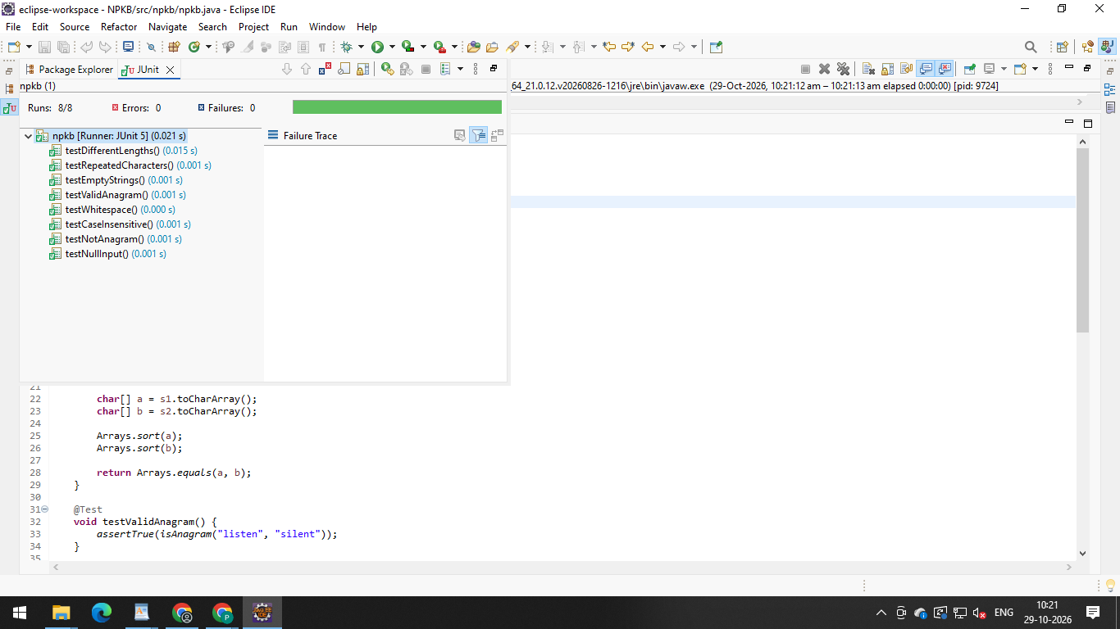

17. To find the maximum of three numbers and validate output using JUnit
assertions.

Code:
Maximum:
package maximum;
public class Maximum {
public static int findMax(int a, int b, int c) {
return Math.max(a, Math.max(b, c));
}

}

Maximum Test:
package maximum;
import org.junit.jupiter.api.Test;
import static org.junit.jupiter.api.Assertions.*;
public class MaximumTest {
@Test
void testMaximum() {
assertEquals(9, Maximum.findMax(3, 9, 5));
assertEquals(10, Maximum.findMax(10, 2, 4));
assertEquals(7, Maximum.findMax(1, 2, 7));
assertEquals(5, Maximum.findMax(5, 5, 2));
}
}

Report:

S. No. | Test Case | Input(a,b,c) | Expected Result
1 | Maximum is the second number | (3,9,5) | 9
2 | Maximum is the first number | (10, 2, 4) | 10
3 | Maximum is the third number | (1, 2, 7) | 7
4 | Two numbers are equal | (5, 5, 2) | 5
Code output:
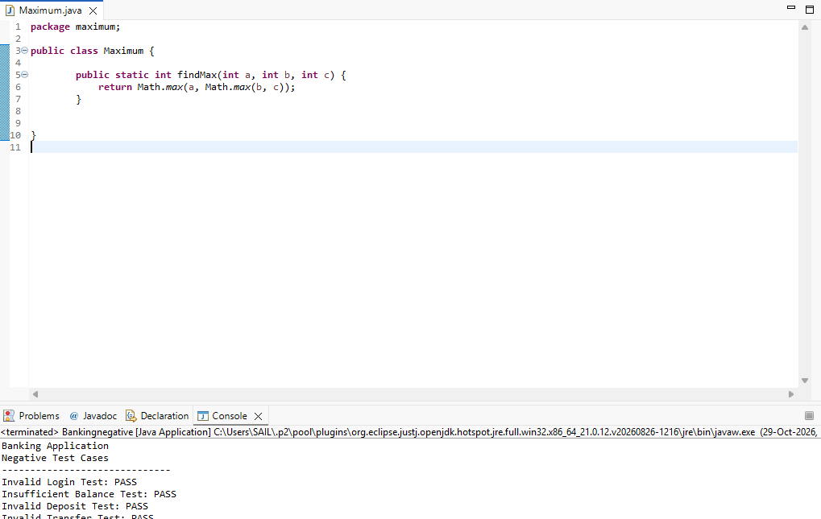
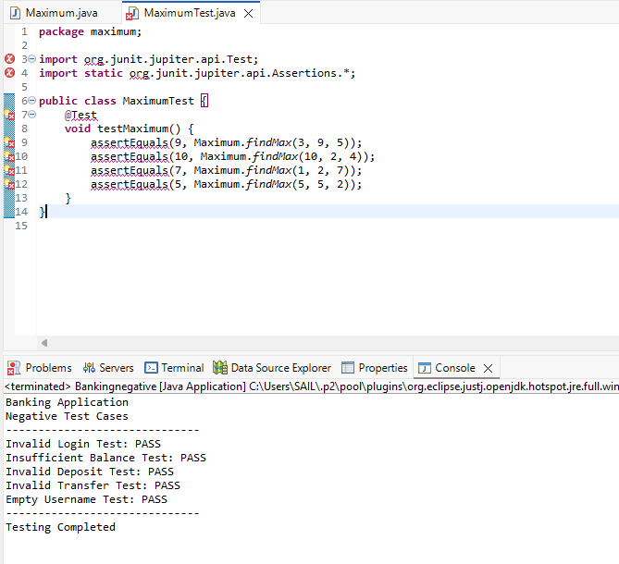

18. To check whether a number is even or odd and validate output using JUnit
assertions.

Code:
package npkb;
import org.junit.jupiter.api.Test;
import static org.junit.jupiter.api.Assertions.*;
public class npkb {
public String checkEvenOdd(int n) {
if (n % 2 == 0)
return "Even";
else
return "Odd";
}
@Test
public void testEvenNumber() {
assertEquals("Even", checkEvenOdd(10));
}
@Test
public void testOddNumber() {
assertEquals("Odd", checkEvenOdd(15));
}
@Test
public void testZero() {
assertEquals("Even", checkEvenOdd(0));
}
}

Report:
S. No. | Test Scenario | Input(N) | Expected Result | JUnit Assertion
1. | Even number | 10 | Even | assertEquals("Even", checkEvenOdd(10))
2 | Odd number | 15 | odd | assertEquals("Odd", checkEvenOdd(15))
3 | zero | 0 | even | assertEquals("Even", checkEvenOdd(0))
Note:
JUnit assertions are used to verify the expected output.
Even numbers are divisible by 2, while odd numbers are not.
Zero is considered an even number.
White-box testing verifies both branches of the if-else statement.
Result: Thus, the even-or-odd checking program was executed successfully, and all three test cases were validated using JUnit assertions.

Code output:
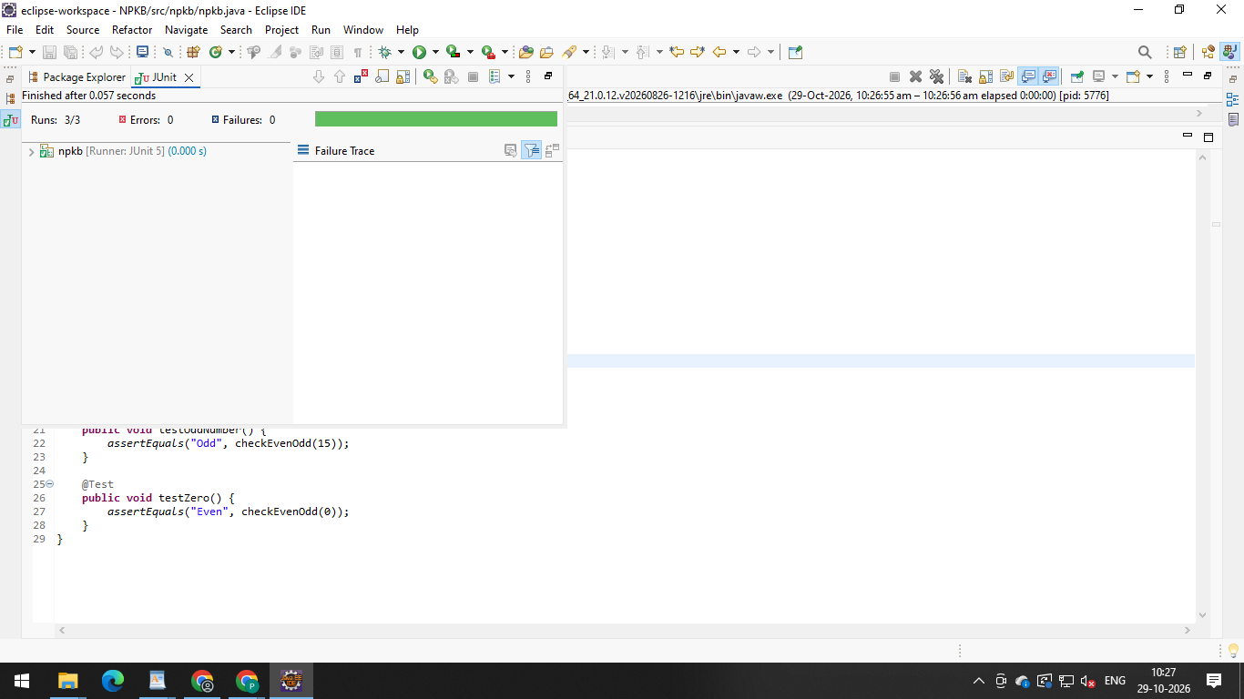
19. To calculate compound interest and validate output using JUnit assertions.
Code:
CompoundInterest:
package maximum;
public class CompoundInterest {
public static double calculate(double p, double r, int n) {
return p * Math.pow(1 + r / 100, n) - p;
}
}
CompoundInterestTest:
package maximum;
import org.junit.jupiter.api.Test;
import static org.junit.jupiter.api.Assertions.*;
public class CompoundInterestTest {
@Test
void testInterest() {
assertEquals(210.0,
CompoundInterest.calculate(1000, 10, 2), 0.01);
assertEquals(100.0,
CompoundInterest.calculate(1000, 10, 1), 0.01);
assertEquals(0.0,
CompoundInterest.calculate(1000, 0, 2), 0.01);
}
}
Report Table:
S.No. | Principal (₹) | Rate (%) | Time (Years) | Expected Interest (₹)
1 | 1000 | 10 | 2 | 210
2 | 1000 | 10 | 1 | 100
3 | 1000 | 0 | 2 | 0
Code Output:
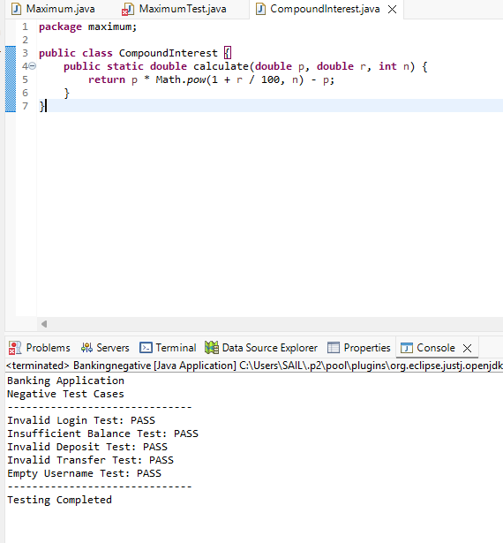
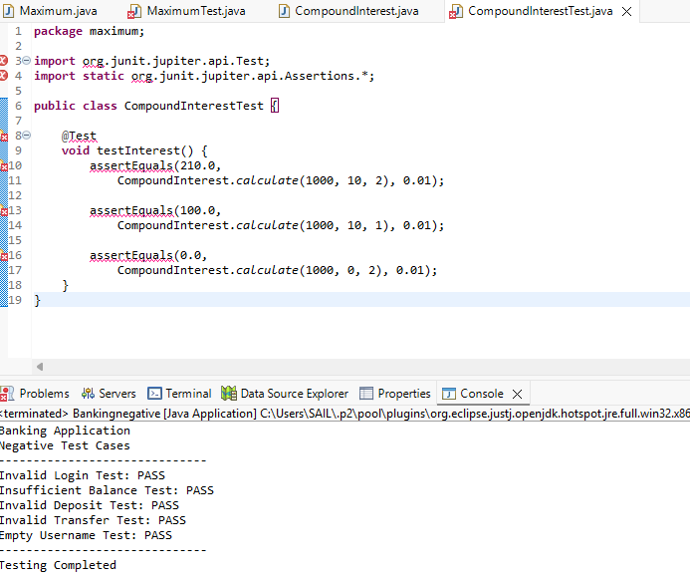
20. To count the number of vowels and consonants in a given string and
validate output using JUnit assertions.
Code:
package junit;

import org.junit.jupiter.api.Test;
import static org.junit.jupiter.api.Assertions.*;

public class VowelConsonantCountTest {

public int[] countVowelsConsonants(String s) {
int vowels = 0, consonants = 0;
s = s.toLowerCase();

for (int i = 0; i < s.length(); i++) {
char ch = s.charAt(i);

if (ch >= 'a' && ch <= 'z') {
if (ch == 'a' || ch == 'e' || ch == 'i'
|| ch == 'o' || ch == 'u')
vowels++;
else
consonants++;
}
}
return new int[]{vowels, consonants};
}

@Test
public void testVowelConsonantCount() {
int[] result = countVowelsConsonants("hello");
assertEquals(2, result[0]);
assertEquals(3, result[1]);
}

@Test
public void testOnlyVowels() {
int[] result = countVowelsConsonants("aeiou");
assertEquals(5, result[0]);
assertEquals(0, result[1]);
}

@Test
public void testOnlyConsonants() {
int[] result = countVowelsConsonants("bcdf");
assertEquals(0, result[0]);
assertEquals(4, result[1]);
}
}

Output:

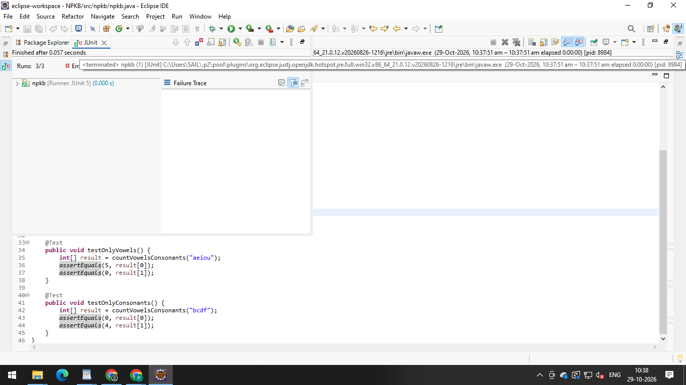

Report Table:

S. No. | Test Scenario | Input | Expected Result | JUnit Assertion
1 | Count vowels and consonants | hello | Vowels = 2, Consonants = 3 | assertEquals(2, result[0]), assertEquals(3, result[1])
2 | Only vowels | aeiou | Vowels = 5, Consonants = 0 | assertEquals(5, result[0]), assertEquals(0, result[1])
3 | Only consonants | bcdf | Vowels = 0, Consonants = 4 | assertEquals(0, result[0]), assertEquals(4, result[1])

